Übung 1:
7. stark konserviert, z.B. GLY 8B und CYS 7B
10. alpha-helical A 7 + 7 AS; B 13 + 3 AS
11. >3i40_B mol:protein length:30
FVNQHLCGSHLVEALYLVCGERGFFYTPKA
>3i40_A mol:protein length:21
GIVEQCCTSICSLYQLENYCN.
DISULFID 31-96, DISULFID 43-109, DISULFID 95-100.
16.
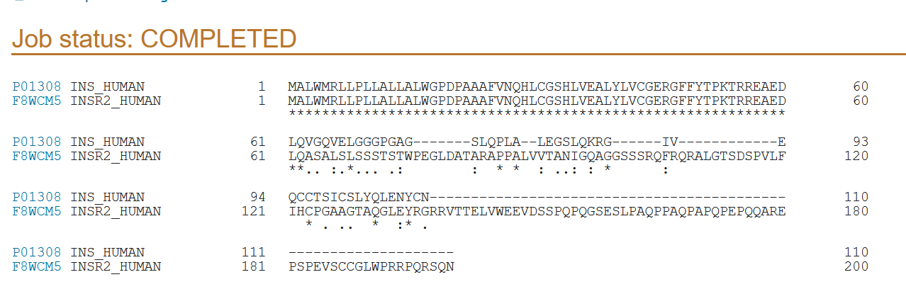
17.
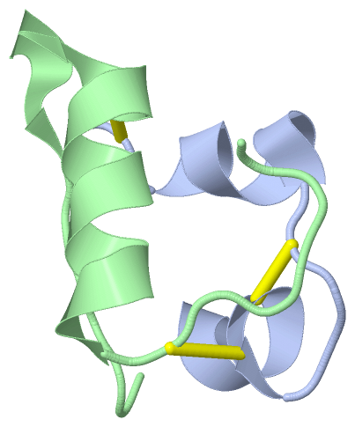 (png)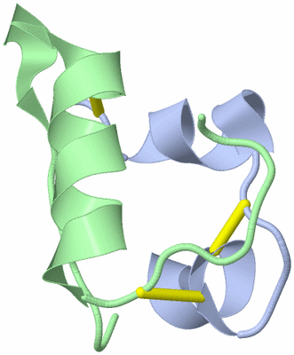 (gif)

Übung 2:
2. Salivary Amylase Alpha 1A, Amylase Alpha 2B (Pancreatic), Amylase, Alpha 2A; Pancreatic, Amylase, Alpha 1B; Salivary, Amylase, Salivary, Alpha-1C
5. 1p21.1
6. amylase alpha-1, salivary cluster including
AMY1A, AMY1B, AMY1C, AMYP1 with ERVA1A, ERVA1B, ERVA1C, upstream and overlapping AMY1A, AMY1B, AMY1C, respectively, amylase-2 pancreatic including AMY2A, AMY2B with ACTGP3 upstream and overlapping AMY2B, and an endogenous retrovirus sequence with a LTR and a gamma-actin sequence overlapping 5'utr and promoter region of AMY2A
EC. number 3.2.1.1
7.
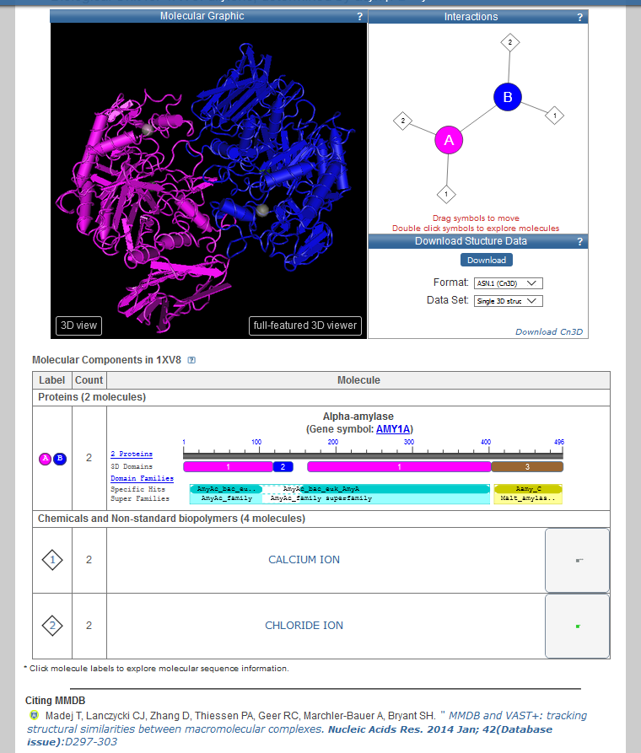
8. ORIGIN
1 xyssntqqgr tsivhlfewr wvdialecer ylapkgfggv qvsppnenva ihnpfrpwwe
61 ryqpvsyklc trsgnedefr nmvtrcnnvg vriyvdavin hmcgnavsag tsstcgsyfn
121 pgsrdfpavp ysgwdfndgk cktgsgdien yndatqvrdc rlsglldlal gkdyvrskia
181 eymnhlidig vagfridask hmwpgdikai ldklhnlnsn wfpegskpfi yqevidlgge
241 pikssdyfgn grvtefkyga klgtvirkwn gekmsylknw gegwgfmpsd ralvfvdnhd
301 nqrghgagga siltfwdarl ykmavgfmla hpygftrvms syrwpryfen gkdvndwvgp
361 pndngvtkev tinpdttcgn dwvcehrwrq irnmvnfrnv vdgqpftnwy dngsnqvafg
421 rgnrgfivfn nddwtfsltl qtglpagtyc dvisgdking nctgikiyvs ddgkahfsis
481 nsaedpfiai haeskl
9. Länge des Gens: kein Klick Fenster mit mouse over auf AMY1A unter Genomic regions, transcripts, and products: 9033 bp
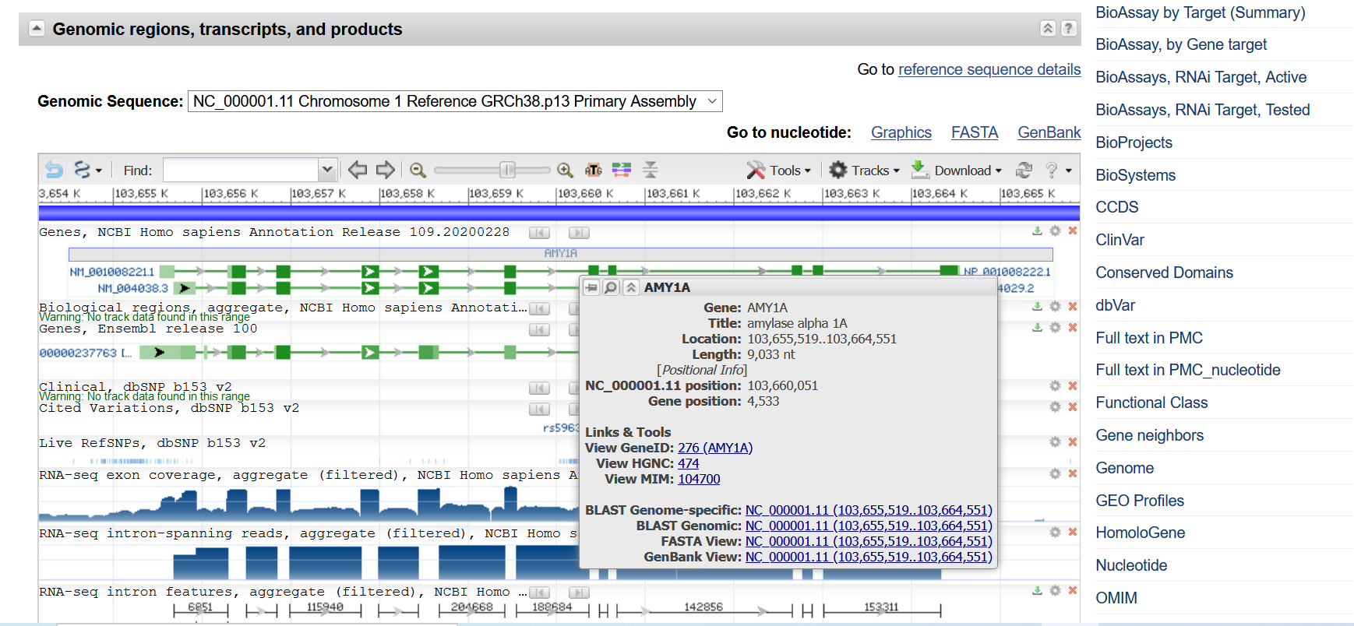
Sequenz: ein Link, über das Tool-Symbol Hammer & Meißel und dann Sequence text view
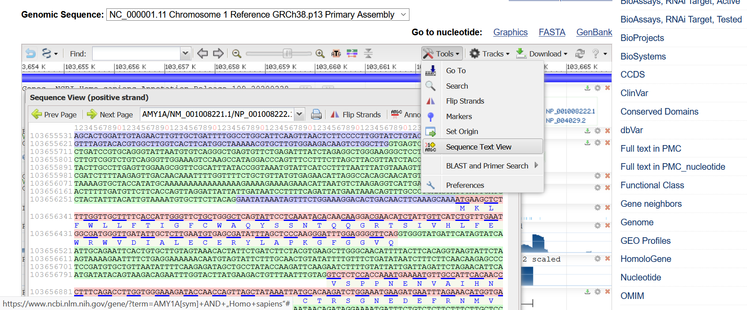

Übung 3:
2. z.B. http://de.wikipedia.org/wiki/Nukleotide (online 19.5.20): D = Nicht-C
4. cytochrome b (mitochondrion) [Homo sapiens]
NCBI Reference Sequence: YP_003024038.1
GenPept Identical Proteins Graphics
>YP_003024038.1 cytochrome b (mitochondrion) [Homo sapiens]
MTPMRKTNPLMKLINHSFIDLPTPSNISAWWNFGSLLGACLILQITTGLFLAMHYSPDASTAFSSIAHIT
RDVNYGWIIRYLHANGASMFFICLFLHIGRGLYYGSFLYSETWNIGIILLLATMATAFMGYVLPWGQMSF
WGATVITNLLSAIPYIGTDLVQWIWGGYSVDSPTLTRFFTFHFILPFIIAALATLHLLFLHETGSNNPLG
ITSHSDKITFHPYYTIKDALGLLLFLLSLMTLTLFSPDLLGDPDNYTLANPLNTPPHIKPEWYFLFAYTI
LRSVPNKLGGVLALLLSILILAMIPILHMSKQQSMMFRPLSQSLYWLLAADLLILTWIGGQPVSYPFTII
GQVASVLYFTTILILMPTISLIENKMLKWA

5.
>ENSG00000198727 Ensembl Gene chromosome:GRCh38:MT:1:16569:1 ATGACCCCAATACGCAAAACTAACCCCCTAATAAAATTAATTAACCACTCATTCATCGAC CTCCCCACCCCATCCAACATCTCCGCATGATGAAACTTCGGCTCACTCCTTGGCGCCTGC CTGATCCTCCAAATCACCACAGGACTATTCCTAGCCATGCACTACTCACCAGACGCCTCA ACCGCCTTTTCATCAATCGCCCACATCACTCGAGACGTAAATTATGGCTGAATCATCCGC TACCTTCACGCCAATGGCGCCTCAATATTCTTTATCTGCCTCTTCCTACACATCGGGCGA GGCCTATATTACGGATCATTTCTCTACTCAGAAACCTGAAACATCGGCATTATCCTCCTG CTTGCAACTATAGCAACAGCCTTCATAGGCTATGTCCTCCCGTGAGGCCAAATATCATTC TGAGGGGCCACAGTAATTACAAACTTACTATCCGCCATCCCATACATTGGGACAGACCTA GTTCAATGAATCTGAGGAGGCTACTCAGTAGACAGTCCCACCCTCACACGATTCTTTACC TTTCACTTCATCTTGCCCTTCATTATTGCAGCCCTAGCAACACTCCACCTCCTATTCTTG CACGAAACGGGATCAAACAACCCCCTAGGAATCACCTCCCATTCCGATAAAATCACCTTC CACCCTTACTACACAATCAAAGACGCCCTCGGCTTACTTCTCTTCCTTCTCTCCTTAATG ACATTAACACTATTCTCACCAGACCTCCTAGGCGACCCAGACAATTATACCCTAGCCAAC CCCTTAAACACCCCTCCCCACATCAAGCCCGAATGATATTTCCTATTCGCCTACACAATT CTCCGATCCGTCCCTAACAAACTAGGAGGCGTCCTTGCCCTATTACTATCCATCCTCATC CTAGCAATAATCCCCATCCTCCATATATCCAAACAACAAAGCATAATATTTCGCCCACTA AGCCAATCACTTTATTGACTCCTAGCCGCAGACCTCCTCATTCTAACCTGAATCGGAGGA CAACCAGTAAGCTACCCTTTTACCATCATTGGACAAGTAGCATCCGTACTATACTTCACA ACAATCCTAATCCTAATACCAACTATCTCCCTAATTGAAAACAAAATACTCAAATGGGCC T

8. z. B. Homo – Pan troglodytes 355/25 von 380 AS; 1011/131 von 1142 Nukleotiden.
9.
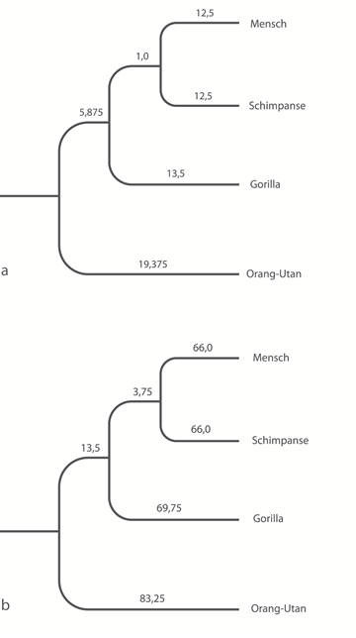
(vgl. https://extras.springer.com/2011/978-3-8274-2785-4.zip unter Graphiken Abb. 15.38 über Windows-Fotoanzeige öffnen und dann kopierbar)

Übung 4:
4. alcohol:NAD+ oxidoreductase
A zinc protein. Acts on primary or secondary alcohols or hemi-acetals with very broad specificity; however the enzyme oxidizes methanol much more poorly than ethanol. The animal, but not the yeast, enzyme acts also on cyclic secondary alcohols.

5.
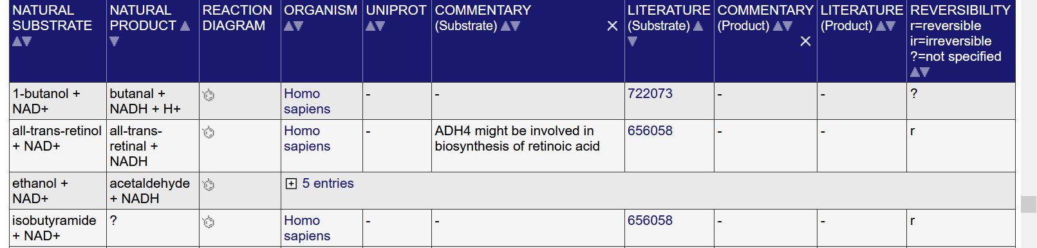

6. z.B. KM values: 0.000035 bis 560 (mM)

7.
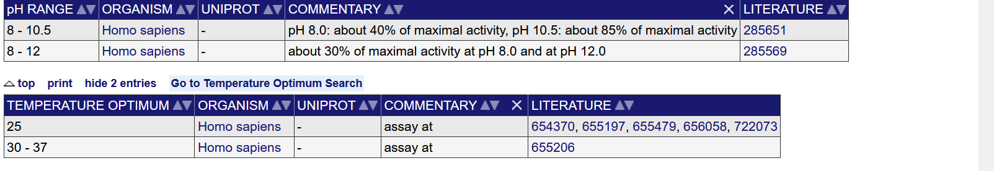
9.
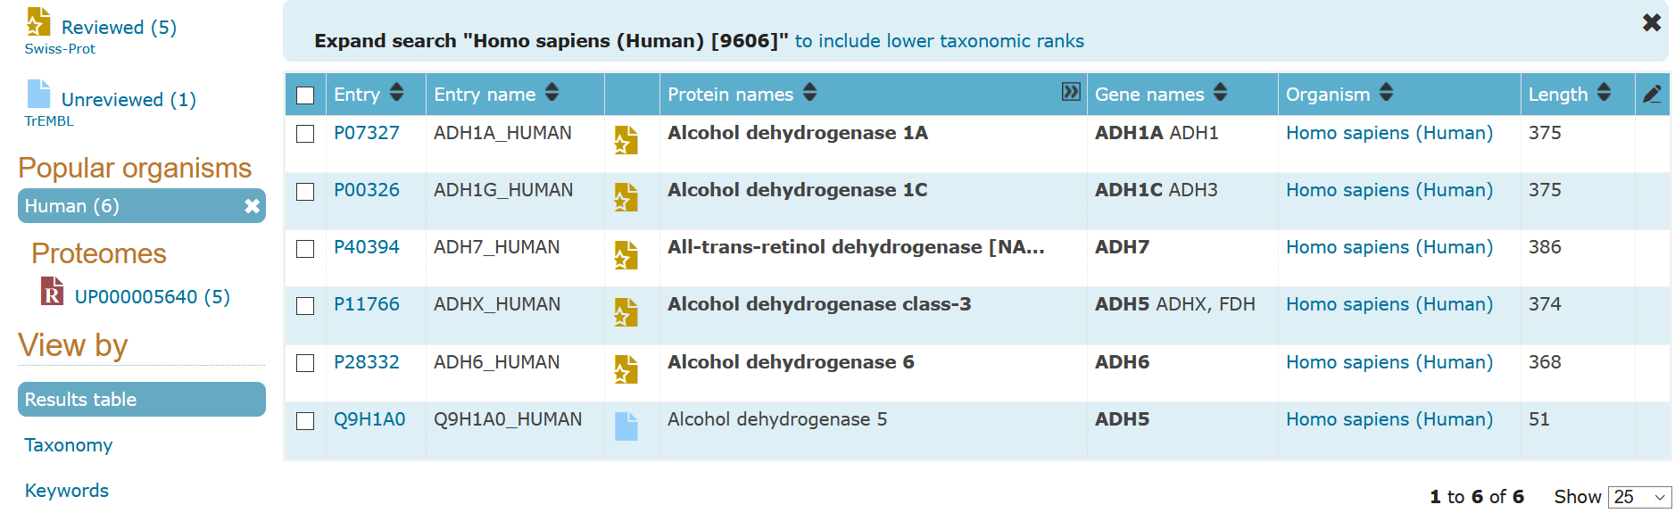

https://www.uniprot.org/align/A20200519216DA2B77BFBD2E6699CA9B6D1C41EB208B7B9I (online 19.5.20).
https://www.ncbi.nlm.nih.gov/Structure/pdb/1XV8 (online 11.5.21).
https://www.ncbi.nlm.nih.gov/gene/?term=AMY1A%5Bsym%5D+AND+%E2%80%9EHomo+sapiens%E2%80%9C (online 11.5.21).
a.a.O.
https://www.uniprot.org/uniprot/?query=%22ec1%201%201%201%22&fil=organism%3A%22Homo+sapiens+%28Human%29+%5B9606%5D%22&sort=score , online 11.5.21.

